Ultrasound Project
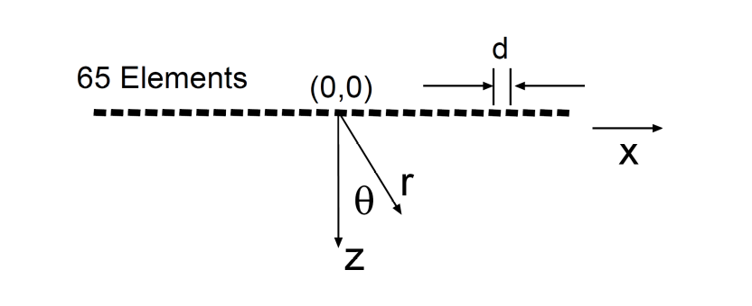
In this project, you will implement the beamforming and scan conversion algorithms for a simulated ultrasound system (above). This system is a little different than most discussed in class in that this system uses only a single transmit element (the (0,0) element at the center of the array) which illuminates all reflectors in the object and the receive array focusing and beam steering is used to provide all lateral localization – that is, we will use one data set to create the entire image of the object.

System description:
Number of elements = 65
Operating frequency (f0) = 4 MHz
Element spacing (d) = λ/2
The simulated data was generated according to the following assumptions:
Speed of sound (c) = 1.54 mm/μs
No attenuation (no gain compensation needed)
Point receivers (w infinitely small)

The simulated echoes are sampled at fs = 16 MHz yielding a 1500 point waveform for each of the 65 array elements. I will provide you with this 1500x65 matrix. Your task is to take this data and generate a 90° sector scan image using by following the steps described below.

Questions/Tasks:
Prepare a report describing the tasks below. Hand in answers to questions below, all requested plots/graphs/images and copies of your final “.m” files. For each question/task please write 2 or 3 sentences about what you did, what equation you implemented, and about the appearance of the resultant images, etc. Say something interesting!

- Make a wavefield plot of the data. We will provide software to image the wavefield. The wavefield is defined as a 1500 x 65 image of the raw ultrasonic data. The gray scale is setup so that zero pressure is midgray, positive pressure is white and negative pressure is black. The “showimage” script sets up the 1500 x 65 image into 4-panel format. Your response to this may be combined with that of part K.

- Define the number of total beams and the beam spacing to properly sample a 90° sector.

- Define time delays (i.e., sampling delays) as a function of range (r) for each channel and beam direction. What formulae were implemented?

- 1. I have placed 2 solitary reflectors along θ = 0 at range locations r = 8 and 15 mm. Create the θ = 0 beam by computing the coherent sum across the array using the delays derived in part C. Before combining data from the detector elements, make plots of delayed from several of the receive elements (e.g. 1, 33, and 65) to insure that pulses and waves will add constructively for those two reflectors.
2. Create data for the r-sinθ buffer for all beams. Use showimage function to display results using a 40 dB log scale.

- Baseband convert the data to provide complex representations of the signal on every channel. Use baseband.m to perform this operation (no modifications are necessary). Plot the signals for one element before and after baseband conversion. Is this what you expect?

- In addition to the time delays (part C.), calculate the phase rotations as a function of range for each channel and beam direction. Again, what formulae were implemented?

- Create data for the r-sinθ buffer for all beams using the baseband converted data. You can again look at θ = 0 beam to make sure that wavefronts add constructively. Display results on 40 dB scale. Is this image better than the result from part D and why?

- To look at the issue of aliasing, construct the r-sinθ buffer for all beams using only the odd numbered channels from the baseband data. Display results on 40 dB scale. What sorts of artifacts do you see and why?

- Scan convert the r-sinθ buffer to produce a sector scan image for a 512 by 512 pixel grid. You should display two images over a log scale, one of 40 dB and the other of 20 dB. The sector scan should be to a range of 60 mm. This means that the dimension of each pixel in the final image should be Δx=Δy=(60/512)mm, which represents about 117 μm per pixel. Again, we will provide software to display the images on a log scale. Do this both for your answers to E and F.

- What is the object? Use the 20 dB image from part G to answer this question. What artifacts are present? Use the 40 dB display to answer this. What does the point spread function look like? Also discuss differences in the artifacts between the images created by the processing of parts D, G and H.

- Based on your new knowledge of what the object is, go back to the wavefield plot of part A and discuss why it looks the way it does. Discuss the angle and curvature of reflections off of the pointobjects and what that says about their location.

